READ CLOCKS
KS1 – 2002 Paper
1.
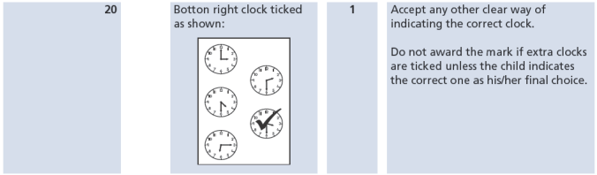
KS1 – 2004 Paper 1
1.
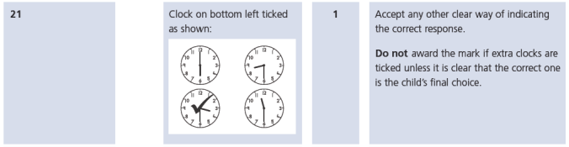
KS1 – 2005 Paper 1
1.
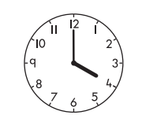
KS1 – 2016 Paper - Reasoning
1.
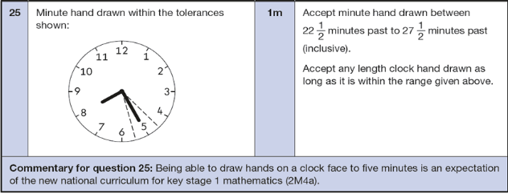

KS1 – 2016 Paper – Reasoning (Second)
1.
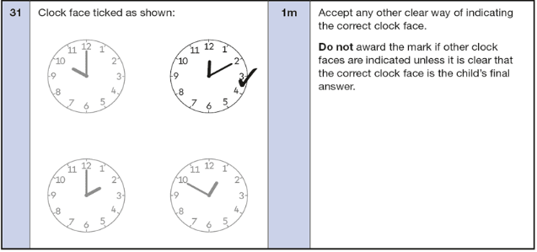
KS1 – 2017 Paper – Reasoning
1.
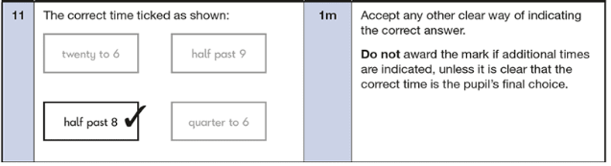
KS1 – 2019 Paper – Reasoning
1.
